What is mental health?  Mental health includes our emotional, psychological, and social well-being. It affects how we think, feel, and act. It also helps determine how we handle stress, relate to others, and make healthy choices. Mental health is important at every stage of life, from childhood and adolescence through adulthood.  What is mental illness?  Mental illnesses are conditions that affect a person’s thinking, feeling, mood or behavior, for example: depression, anxiety, bipolar disorder, or schizophrenia. They maybe occasional or long-lasting (chronic) and affect a person’s ability to relate to others and function normally each day.  These terms are often used interchangeably. But poor mental health and mental illness are not the same things. A person can experience poor mental health and not be diagnosed with a mental illness. Likewise, a person diagnosed with a mental illness can experience periods of physical, mental & social well-being |  |  | Why is mental health important for overall health?  Mental and physical health are equally important components of overall health. Mental illness, especially depression, increases the risk for many types of physical health problems, particularly long-lasting conditions like stroke, type 2 diabetes, and heart disease. Similarly, the presence of chronic conditions can increase the risk for mental illness.  Can mental health change over time?  A person’s mental health can change over time, depending on many factors. When the demands placed on a person exceed their resources and coping abilities, their mental health could be impacted. Eg: working long hours, job loss, economic hardship, illness for self or family etc.  Reference |  |  | - References: https://www.cdc.gov/mentalhealth/learn

Impact of Mental Illness  Suicide, which is often associated with symptoms of mental illness, is the 10th leading cause of death the U.S. and the 2nd leading cause of death among people aged 15-34.  Serious mental illness costs in the United States amount to $193.2 billion in lost earnings per year.  Mood disorders, including major depression, dysthymic disorder, and bipolar disorder, are the third most common cause of hospitalization in the United States. for both youth and adults aged 18 to 44.  Individuals living with serious mental illness face an increased risk of physical health problems, such as heart disease, diabetes.  U.S. adults living with serious mental illness die on average 25 years earlier than others.  Awareness and Prevention  Preventing mental illness and promoting good mental health involves actions to create living conditions and environments that support mental health and allow people to adopt and maintain healthy lifestyles. |  |  | Matters  Recognizing common signs of distress:  - Feelings of feelings of fear, anger, sadness, worry, numbness, or frustration  - Changes in appetite, energy, and activity levels  - Difficulty concentrating and making decisions  - Difficulty sleeping or nightmares  - Physical signs: headaches, body pains, stomach problems, and skin rashes  - Worsening of chronic health problems  - Increased use of alcohol, tobacco, or other drugs  We likely know someone who has experienced poor mental health or mental illness at some point in their lives. Yet there are still many harmful attitudes and misunderstandings around mental health and mental illness, which lead to ignorance, fuel stigma about mental illness, and make it harder to reach out for help. Take the following quiz to separate the myths from the facts.  https://www.cdc.gov/mentalhealth/quiz/index.htm  Concerned about your mental health  Take a Quiz  https://www.cdc.gov/mentalhealth/quiz/index.htm |  |  | 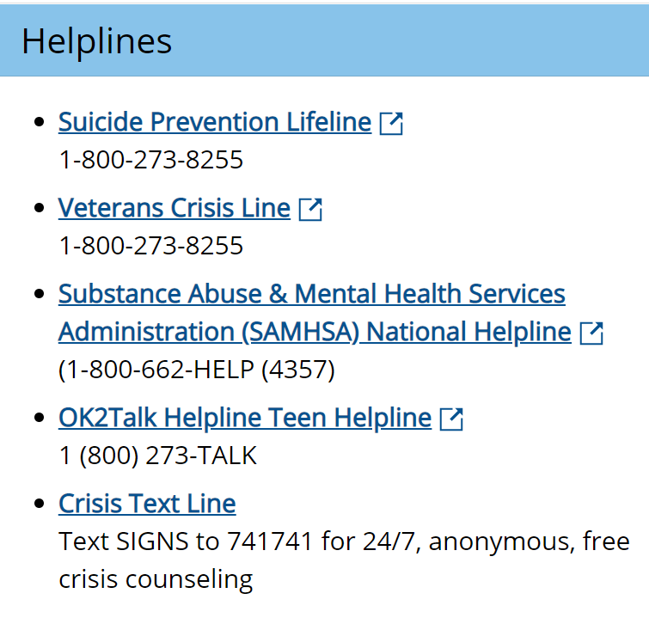  Apps to help with Mental Health  